MAMBANO PROJECTS FOUNDATION
HURUNGWE REGION DISTRIBUTION
DATE:29 OCTOBER 2024
VENUE: CHARLES CLARK MAGUNJE

BRIEF REPORT
The distribution process started by collection of seven Clothes boxes from Harare. Collection was done on the 28th of October 2024 as shown on picture below:
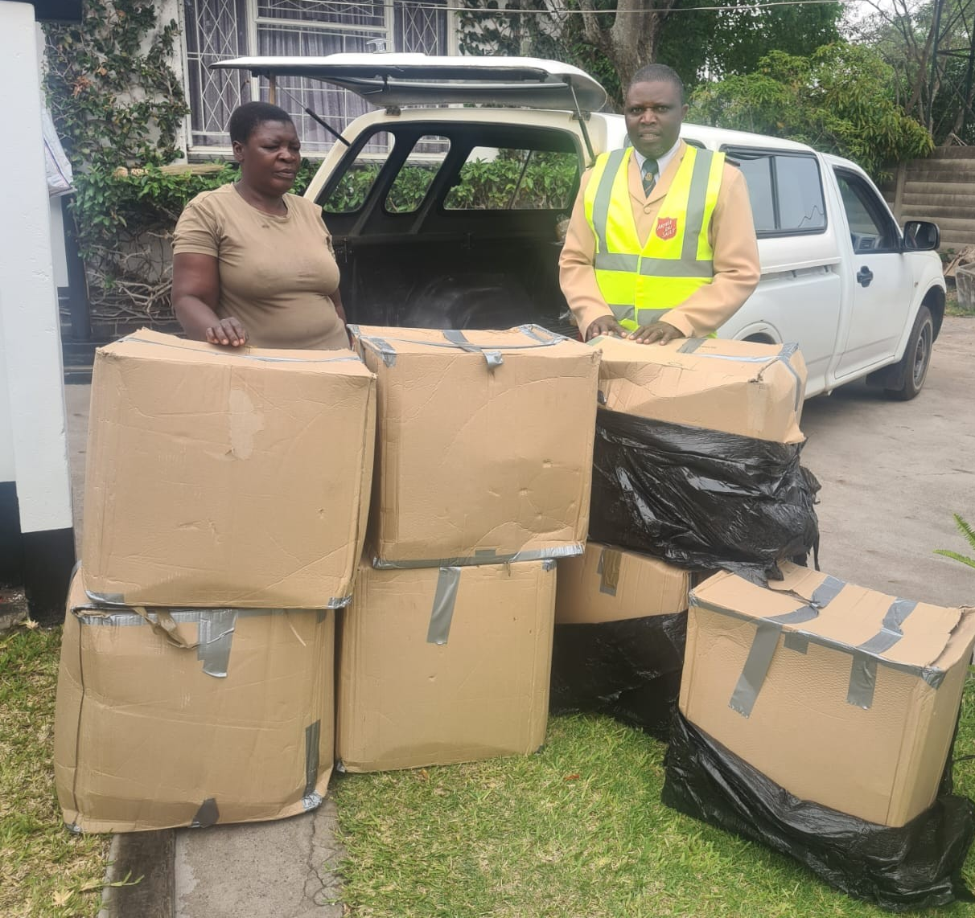

On the 29th boxes of clothes were taken to Magunje Hurungwe. The Salvation army provided transport (vehicle) and driver while the donor funded all transport costs and tollgates ($170). Major L Bulawayo the Divisional Commander had invited vulnerable members of the surrounding communities like Charles Clark, Maumbe, Kebvunde and Chishumba, respectively.
Distribution started at 1100 hours with a word of prayer, introductions, and brief information about the donor (Mambono Projects Foundation). We made sure clothes were sorted according to age and gender with help from few selected individuals. Men got first preference to get in and receive the gift. In few minutes they wore smiles holding great outfits in their hands. They then left space for their female counterparts to explore the wonder. The women agreed that they would queue and rotate picking from each section until everything was taken.
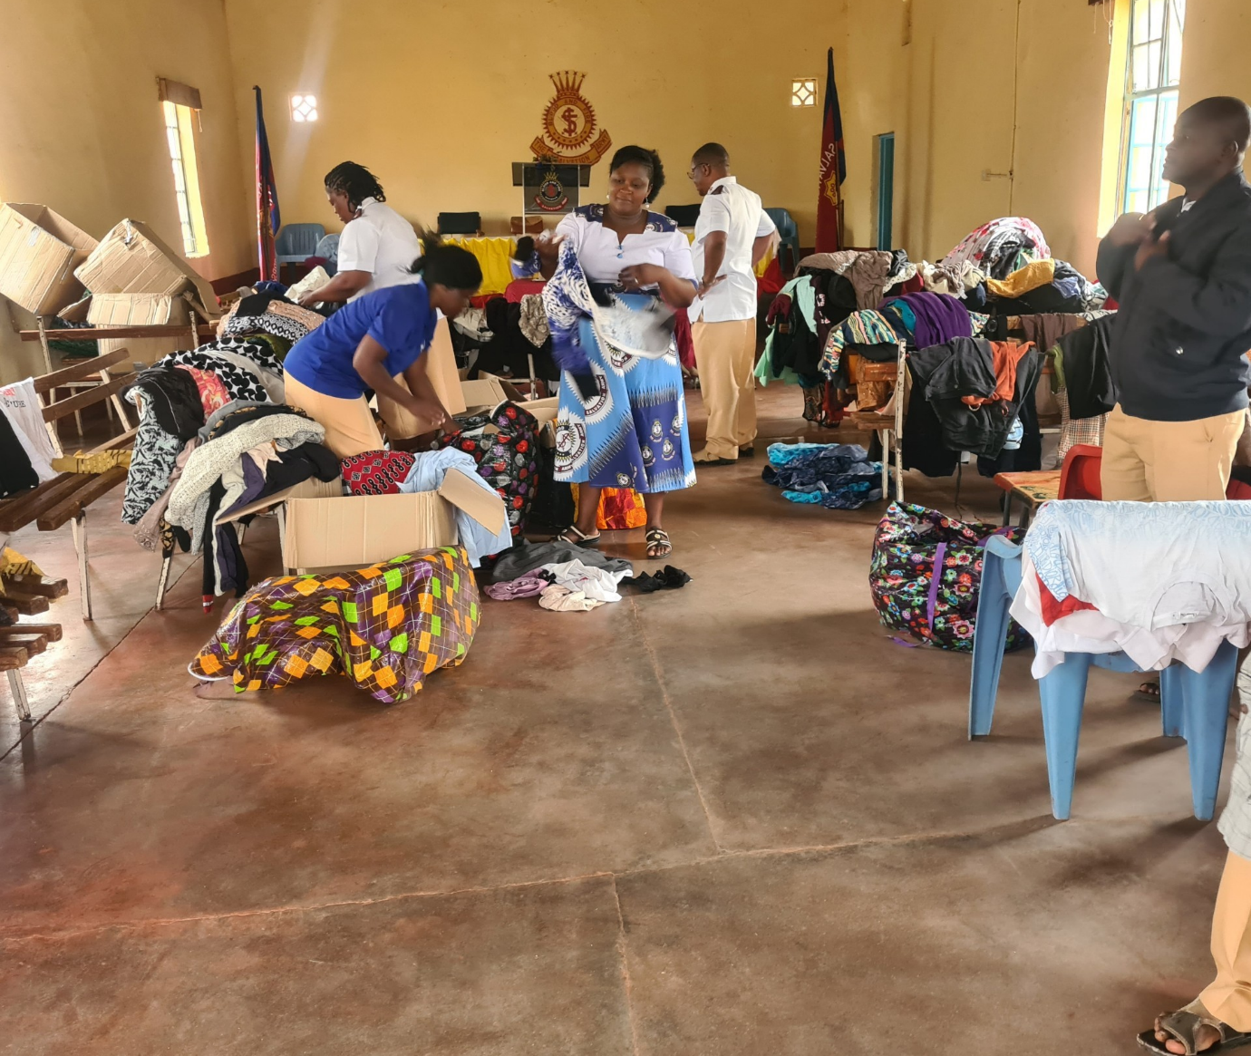

When all participants had grabbed their gift, we asked both men and women to go out for photos and testimonies.

BENEFICIARIES:

MALE: 11
FEMALE 40

TOTAL RECIPIENTS 51

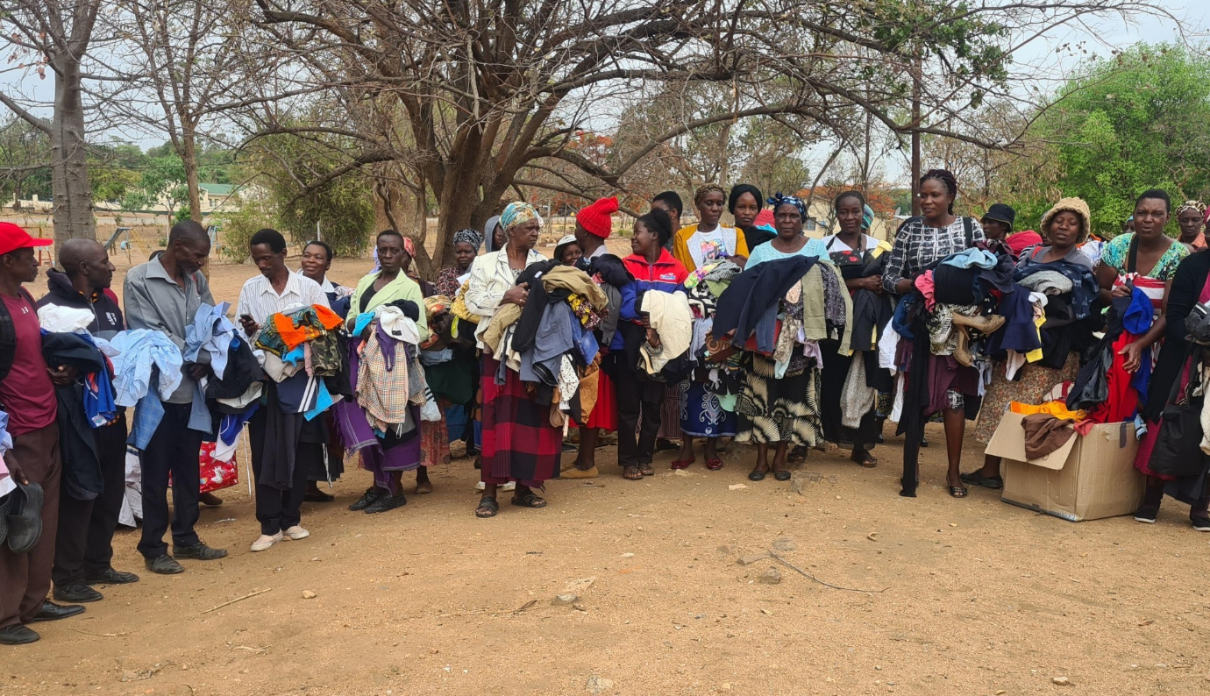

Report compiled by Major Tapera Foroma
Territorial Public Relations Secretary
FOR THE SALVATION ARMY

